Aim: Understanding and implementing widgets in Flutter

Theory:

Q1. What is Dart Language?
Dart is an object-oriented, open-source programming language developed by Google. It is mainly used for building mobile, web, and desktop applications, especially with the Flutter framework.

Features of Dart:
- Object-oriented programming language
- Supports JIT (Just-In-Time) and AOT (Ahead-Of-Time) compilation
- Simple and readable syntax similar to Java and C++
- High performance with fast execution

Q2. Why Flutter Uses Dart?
- Fast Performance – Dart compiles directly into native machine code
- Hot Reload – Allows instant UI updates without restarting the app
- Single Codebase – Same code works for Android and iOS
- Optimized UI Rendering – Smooth animations and transitions
- Easy to Learn – Clean and beginner-friendly syntax

Q3. What is Widget in Flutter?
A widget is the basic building block of a Flutter application. Everything visible on the screen in Flutter is a widget.

Examples of widgets include:
- Text
- Buttons
- Images
- Layout widgets like Row and Column

Widgets describe how the user interface should look.

Q4. What is Stateless Widget?
A Stateless Widget is a widget whose state does not change during runtime.

Characteristics:
- User interface remains constant
- No internal data change
- Faster performance
Example:
A simple text widget displaying “Hello Flutter”.

Q5. What is Stateful Widget?
A Stateful Widget is a widget whose state can change during runtime.

Characteristics:
- UI changes dynamically
- Uses “setState()” method
- Suitable for interactive applications

Example:
A counter application where the displayed value increases when a button is pressed.

Q6. Steps to develop a Calculator using flutter:
- Open Android Studio.
- Create a new Flutter project.
- Set the project name and location.
- Open the “main.dart” file.
- Write the calculator application code using Stateless and Stateful widgets.
- Use buttons for numbers and operators.
- Implement basic arithmetic operations.
- Run the application using an Android emulator.

Code (main.dart):

import 'package:flutter/material.dart';
void main() {
runApp(const MyApp());
}
class MyApp extends StatelessWidget {
const MyApp({super.key});
@override
Widget build(BuildContext context) {
return MaterialApp(
title: 'Flutter Calculator',
theme: ThemeData(
colorScheme: ColorScheme.fromSeed(seedColor: Colors.deepPurple),
useMaterial3: true,
),
home: const CalculatorApp(),
);
}
}
class CalculatorApp extends StatefulWidget {
const CalculatorApp({super.key});
@override
State<CalculatorApp> createState() => _CalculatorAppState();
}
class _CalculatorAppState extends State<CalculatorApp> {
String _display = '0';
String _expression = '';
double _firstNumber = 0;
double _secondNumber = 0;
String _operation = '';
bool _shouldClearDisplay = false;
void _handleButtonPress(String buttonText) {
_operation = '';
_firstNumber = result;
_shouldClearDisplay = true;
}
} else if (['+', '-', '*', '/'].contains(buttonText)) {
// Handle operations
if (_operation.isEmpty) {
_firstNumber = double.tryParse(_display) ?? 0;
_operation = buttonText;
_expression = '$_firstNumber $buttonText ';
_shouldClearDisplay = true;
} else {
// If an operation already exists, calculate first
_secondNumber = double.tryParse(_display) ?? 0;
double result = _calculate();
_firstNumber = result;
_operation = buttonText;
_expression = '$result $buttonText ';
_display = result.toString();
if (_display.endsWith('.0')) {
_display = _display.substring(0, _display.length - 2);
}
_shouldClearDisplay = true;
}
} else {
// Handle numbers and decimal point
if (_shouldClearDisplay) {
_display = '';
_shouldClearDisplay = false;
}
if (buttonText == '.') {
if (!_display.contains('.')) {
_display += buttonText;
}
} else {
if (_display == '0') {
_display = buttonText;
} else {
_display += buttonText;
}
}
if (_operation.isNotEmpty) {
_expression = '$_firstNumber $_operation $_display';
}
}
});
}
double _calculate() {
switch (_operation) {
case '+':
return _firstNumber + _secondNumber;
case '-':
return _firstNumber - _secondNumber;
case '*':
return _firstNumber * _secondNumber;
case '/':
return _secondNumber != 0 ? _firstNumber / _secondNumber : 0;
default:
return 0;
}
}
// Calculator buttons
Expanded(
child: Padding(
padding: const EdgeInsets.all(8.0),
child: Column(
children: [
// First row: C
Row(
children: [
_buildButton('C', Colors.red, Colors.white),
],
),
// Second row: 7, 8, 9, /
Row(
children: [
_buildButton('7', Colors.grey[300]!, Colors.black),
_buildButton('8', Colors.grey[300]!, Colors.black),
_buildButton('9', Colors.grey[300]!, Colors.black),
_buildButton('/', Colors.orange, Colors.white),
],
),
// Third row: 4, 5, 6, *
Row(
children: [
_buildButton('4', Colors.grey[300]!, Colors.black),
_buildButton('5', Colors.grey[300]!, Colors.black),
_buildButton('6', Colors.grey[300]!, Colors.black),
_buildButton('*', Colors.orange, Colors.white),
],
),
// Fourth row: 1, 2, 3, -
Row(
children: [
_buildButton('1', Colors.grey[300]!, Colors.black),
_buildButton('2', Colors.grey[300]!, Colors.black),
_buildButton('3', Colors.grey[300]!, Colors.black),
_buildButton('-', Colors.orange, Colors.white),
],
),
// Fifth row: 0, ., =, +
Row(
children: [
_buildButton('0', Colors.grey[300]!, Colors.black),
_buildButton('.', Colors.grey[300]!, Colors.black),
_buildButton('=', Colors.green, Colors.white),
_buildButton('+', Colors.orange, Colors.white),
],
),
],
),
),
),
],
),
);
}
}

Ouput:
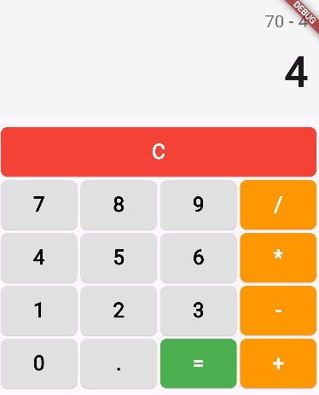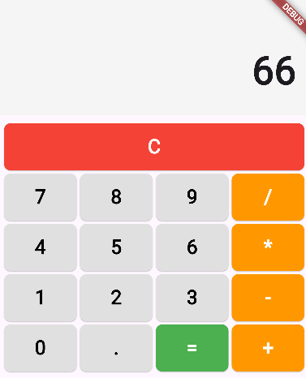

Conclusion:
Flutter widgets provide a powerful and flexible way to build user interfaces. By using Stateless and Stateful widgets together, interactive applications like a calculator can be developed efficiently.

